NAME: VEDIKA NAIDU PRN: 24070521274
APPLICATION LAYER PACKET ANALYSIS USING TRACER
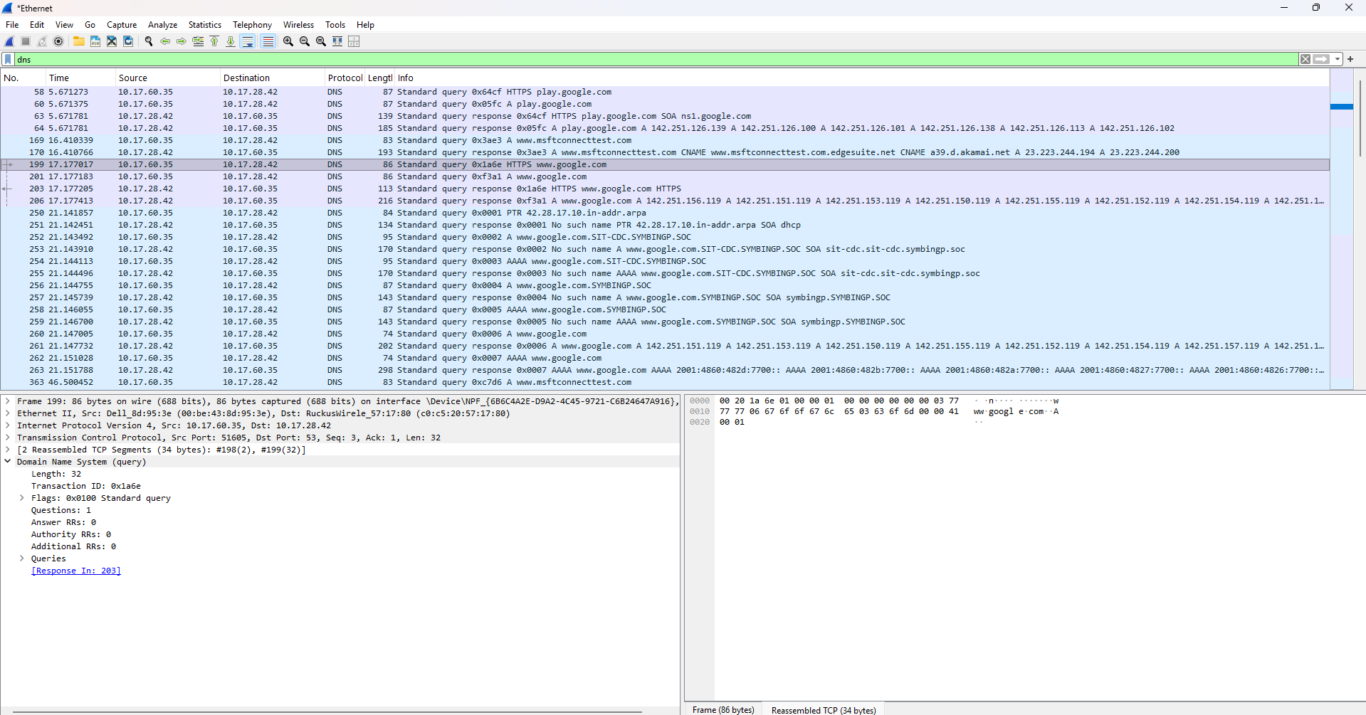

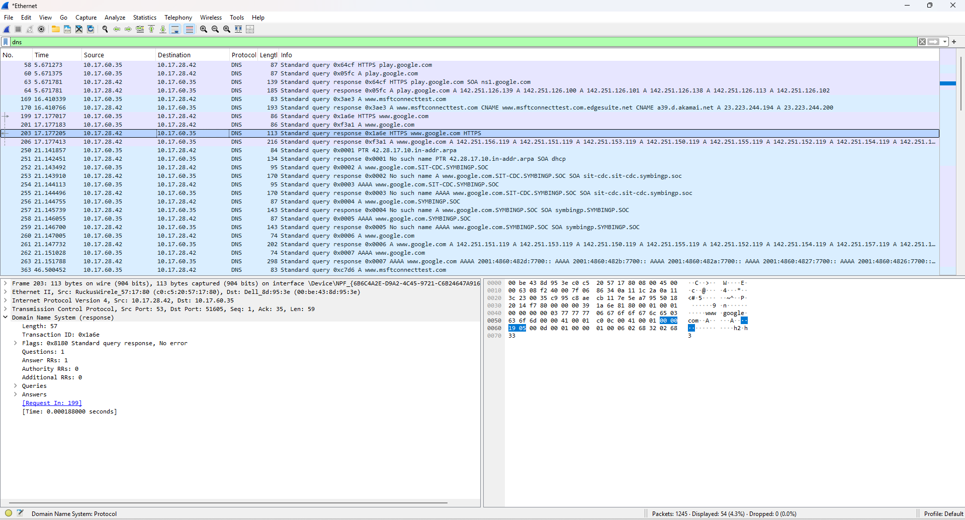

NAME: VEDIKA NAIDU PRN: 24070521274
